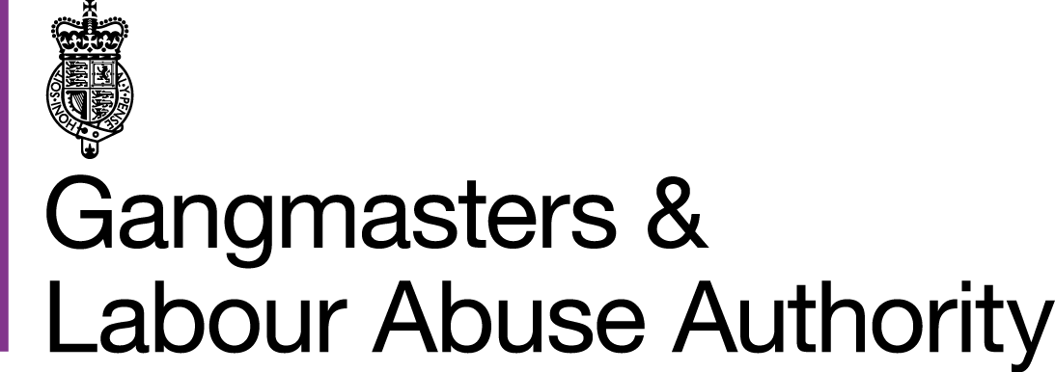

Media Indemnity Agreement

- Agreement between the Gangmasters and Labour Abuse Authority (GLAA) of the first part and the undersigned of the second part.
- In consideration of the use of Gangmasters and Labour Abuse Authority (GLAA) premises, vehicles or other property and/or in consideration of my being allowed to accompany GLAA officers and staff on operational and/or non-operational duties
- For the avoidance of doubt reference to Gangmasters and Labour Abuse Authority (GLAA) means both the organisation as an individual entity and all individual members of staff.

On …………………………………………………… (date) at the following location(s)

………………………………………………………………………………………………….. I, ………………………………………………………….. (name of individual) on behalf of
…………………………………………………………… (name of organisation) hereby agree that:
  - In consideration of the Gangmasters and Labour Abuse Authority (GLAA) authorising me, the undersigned, to travel in or upon any vehicle or be present on any premises owned or in the control of the GLAA …………………………………………. (name of organisation) agree to hold the said Gangmasters and Labour Abuse Authority, its Chief Executive and the GLAA’s officers, agents and employees indemnified from and against any liability and/or actions, claims, injury (including injury resulting in death), incident, or damage to my property or person, whilst I am in or upon any vehicle or premises owned or in the control of the said GLAA, except where such death, injury or damage results from the negligence of the said Gangmasters and Labour Abuse Authority, its Chief Executive and the GLAA’s officers, agents and employees.

  - ……………………………………………… (name of organisation) agrees to compensate the said Gangmasters and Labour Abuse Authorityin respect of any loss of and/or damage to GLAA property, caused or occasioned by the wrongful or negligent act or omission by myself or ……………………………………………….. (name of organisation).

  - ……………………………………………… (name of organisation) agrees to indemnify the Gangmasters and Labour Abuse Authority, its Chief Executive and the GLAA’s officers, agents and employees against any expense, liability, loss, claim, proceedings damages or costs arising from my participation in the activities described in paragraph B above.

  - That ……………………………………………… (name of organisation) its servants, agents or representatives shall not ask any staff of the GLAA to obtain on their behalf the consent to enter any premises nor shall there be any variation to this indemnity agreement unless the same be in writing and signed by the parties to this indemnity agreement. I agree that it is my sole responsibility to obtain the consent of the occupier/owner before entry in to any premises not covered in this agreement.

- The Gangmasters and Labour Abuse Authority is covered by public liability insurance in respect of any loss, damage or injury caused by proven negligence on the part of the GLAA. The cover does not therefore extend to the loss, damage or injury sustained on a purely accidental basis.

Please read and sign the statement below in acceptance of this agreement. This form must also be counter- signed by a member of staff duly authorised to sign for and on behalf of your organisation.

I acknowledge that I have received a copy of the GLAA ‘Note to Media Representatives.’ We agree to the above terms.

Signed…………………………………………………………………. Date …………………………. (Individual)

Counter-signed ……………………………………………………….. Date …………………………… Print name ……………………………………………………… Position held ………………………… On behalf of …………………………………………………………………. (Name of organisation).

Signed on behalf of the Chief Executive of the Gangmasters and Labour Abuse Authority……………………………………………………………………….. (Signature)
………………………………………………………………………………... (Name)
………………………………………………………………… (Signature)
………………………………………………………………………………... (Name)

GLAA Note to Media Representatives

For the avoidance of doubt reference to the Gangmasters and Labour Abuse Authority (GLAA) means both the GLAA as an individual organisation and all of its officers, agents and employees

Lawful entry on to private premises by media representatives cannot be authorised by the GLAA
Entry on to private premises is a matter between media representatives and adult householder owner or lawful keyholder and not the GLAA. The GLAA will not seek permission on behalf of the media.

If GLAA staff visit private property whilst media representatives are with them it is the responsibility of the media representatives to seek permission from the owner to enter the property before doing so. If permission is not obtained for any reason or is refused by the owner then the media representative must not enter. Consent should be in a form that is capable of proof, i.e. in writing, video or taped verbal comment.

Media representative/s should be mindful of the law of trespass. If they are asked by the adult householder, owner or lawful keyholder to leave private premises, they may exacerbate any offence of trespass if they fail to do so immediately.

The GLAA reserves the right to request media representatives to leave premises; for example, where preservation of evidence and/or operational integrity is necessary or where GLAA officers believe consent to enter was not obtained or consent has been withdrawn.

The GLAA cannot confer rights to media representatives to film, record, or interview scenes or individuals. Consent to do so must be obtained from the occupier or the individual involved, in addition to the consent to enter.

Media representatives are reminded that any material created or obtained by them, including their written notes, sound, video or other recordings may became subject to the laws relating to disclosure. Newsgatherers need to be aware of these laws; for example, the possibility of an application under schedule 1 to the Police and Criminal Evidence Act 1984 for a Judge’s Order that material be disclosed to the police.

Media representatives are reminded that they are not part of any GLAA or law enforcement operation and that they are present as representatives of their own organisation and individuals.

Media representatives are further reminded that under the Human Rights Act entering private property without permission, or taking film or photographs without permission, could interfere with a person’s rights; and the broadcasting or publishing of any material, photographs or film of an individual, their family or private life, their home or correspondence could interfere with a person’s rights.

